[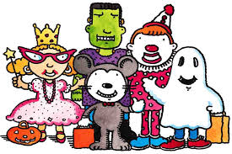](http://www.google.com/url?sa=i&rct=j&q=&esrc=s&source=images&cd=&cad=rja&uact=8&ved=0CAcQjRw&url=http://www.tewksbury.k12.ma.us/HeathBrook.cfm?subpage%3D782982&ei=eXFFVLurPI2tyATGsYLIDA&bvm=bv.77880786,d.aWw&psig=AFQjCNGnRpDgYLOlJjFnIAWdoJZlTHTaaA&ust=1413923558246639)**Preschool for All – AM & PM  
Halloween**

Preschoolers will celebrate Halloween on Wednesday, Oct 30 (there is no school for EC/PreK on Thursday, Oct 31 due to an Early Dismissal).

Students may bring treats to share with friends. Treats must be store bought, contain no nuts, and be individually wrapped. It is not required to bring treats.

All parents and guardians are invited to join us for an outdoor PreK/EC Halloween parade on Wednesday, Oct 30 in the front of the school. AM classes will parade at 8:35am and PM classes will parade at 12:05pm. Students may wear their costumes to school. ***We are asking that costumes and props that suggest violent themes or include weapons are not worn to school.***

Number of children: AM session - 5; PM session – 9